Testing Results:

\* A list of movies

\* The user should be able to search the movies by title

\* The user should be able to filter the movies by rating

\* The user should be able to filter the movies by category

RestAPI

<http://localhost:8090/SampleSpringRest/rest/movies/getByTitle?title=Academy&rating=&category>=

a.)in this API the title of the movie is mandatory and after which user can filter by giving the rating and category

first testcase where we pass only title

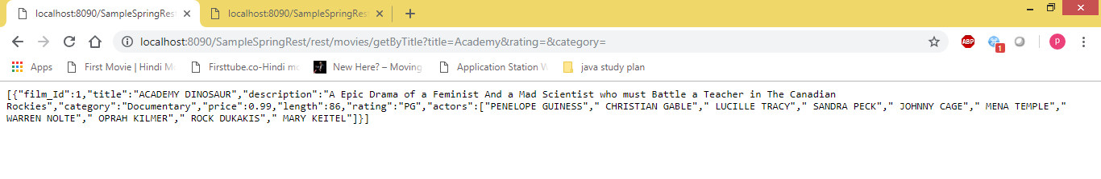

Second testcase where we pass title (which are starting with A)and rating with R

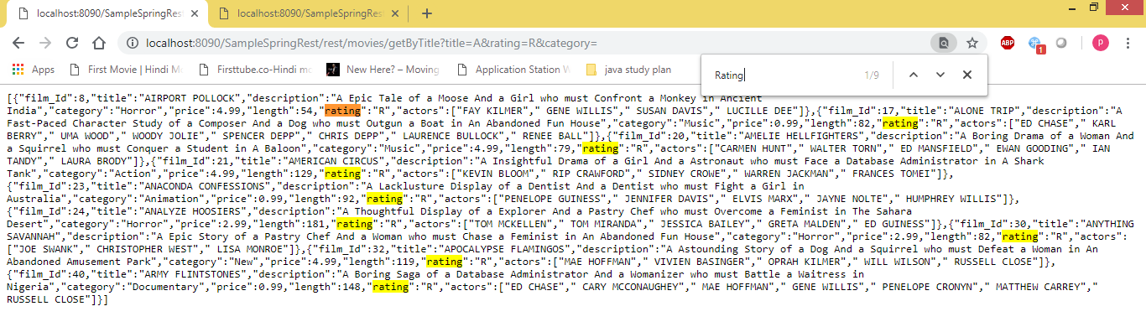

Third testcase where we pass title(which are starting with A) and rating with R and category is music

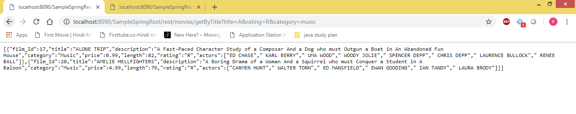

Fourth testcase where we pass tilte(which is starting with A) and category is music

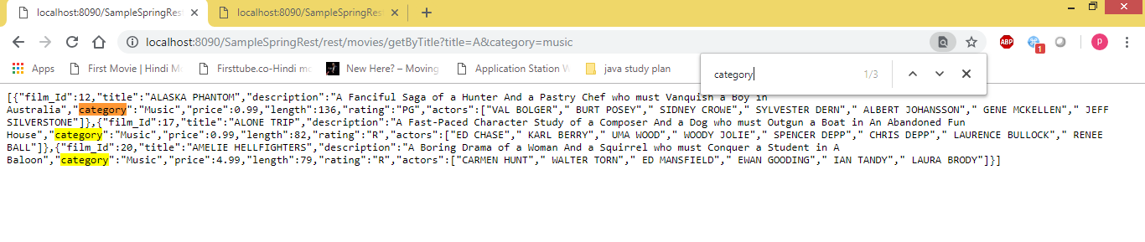

Fifth test case where we pass title(which starts with a), rating(r) and category sports

As there are no movies it will return empty array.

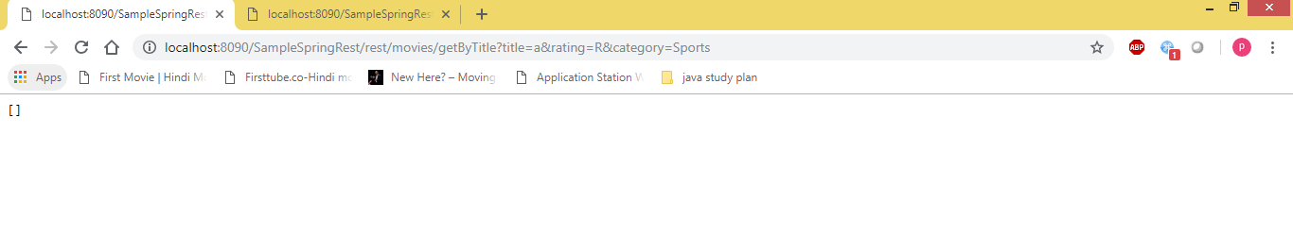

\* Movie details for each movie

Solution:Passing the title of the movie we get details of the movie

RestAPI:

<http://localhost:8090/SampleSpringRest/rest/movies/getByFilmDetails?title=Academy>

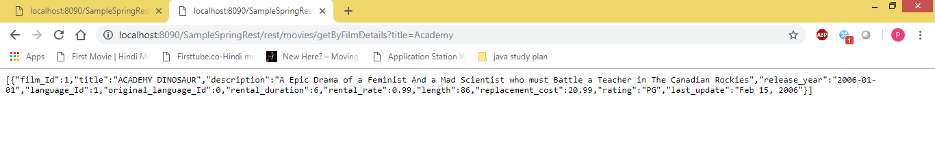

\* A list of actors in a movie

Solution: Passing the title of the movie we get results for the actors in the movie

RestAPI

<http://localhost:8090/SampleSpringRest/rest/movies/getActors?title=Academy>

